Door County Pulse

# Roy Lukes: Attracting Bluebirds

By [Roy and Charlotte Lukes](https://doorcountypulse.com/author/rlukes/), [Peninsula Pulse](https://doorcountypulse.com/issue/peninsula-pulse-may-6-13-2016/) – May 6th, 2016

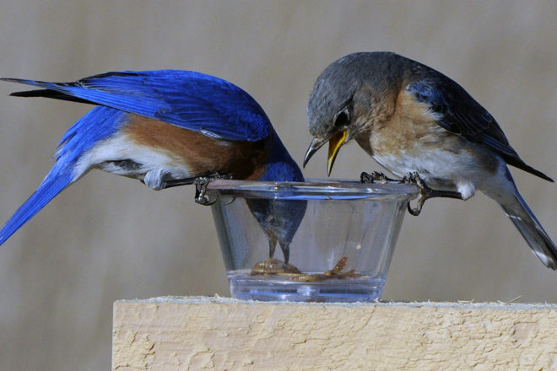

A pair of eastern bluebirds enjoys mealworms placed on top of a box after a cold spell one spring. Photo by Roy Lukes.

Growing up during the 1930s and ‘40s and spending a lot of time on my grandparents’ farm, I never once saw an eastern bluebird there. My dad was born and raised on that farm west of Slovan and he could recall that, as a boy, at least one family of bluebirds nested each summer in one of the hollowed-out cedar fence posts along their driveway within 75 feet of their house.

Eastern bluebirds took a terrible nosedive in population during my youth due to fierce competition for nesting cavities especially from the house sparrows and European starlings, both non-native species. Couple that with an enormous use of bad herbicides and pesticides and other factors, it took quite a few years before the bluebirds began making a comeback.

A call was put out by Wisconsin’s DNR for people to build nest boxes to try to help increase the bluebird population and with that goal BRAW (The Bluebird Restoration Association of Wisconsin) was organized in 1986. They are celebrating their 30th anniversary this year and have attracted many citizens across the state to help all cavity nesting birds.

The BRAW website has information on starting a bluebird trail, building nest boxes, proper placement of the boxes and regular monitoring throughout the nesting season. Get acquainted with the site at braw.org and become a member.

I’ve been building many bluebird nest boxes through the years and we’ve been carefully placing them in the proper habitats and monitoring them regularly, keeping accurate records of the activity in each box. As habitats change we will move a box to a better location for the bluebirds.

There are a number of species that will take a bluebird nest box, including tree swallows, house wrens and black-capped chickadees. Knowing where and how to set your nest box can make all the difference in which species will be attracted to it.

Bluebirds require a large territory, perhaps two to three acres per pair, and expanses of bare ground or short grass in which to find food. They search for insects on the ground so good visibility is very important. You will often see them perched on power lines or other structures looking down for any movement of ground-dwelling insects.

Tree swallows get all their food in the air and will fly as much as four miles from their nest box in search of food. If nest boxes are set too close to one another they may only attract swallows. House wrens prefer shrubby habitats and chickadees will do well in a mix of field and woods.

If you want to attract bluebirds you have to think like a bluebird. Set the box on a pole that no predator can climb and make sure it is high enough from the ground so feral cats can’t jump up to the box. Typical predators besides cats are raccoons, squirrels, snakes, mice and possibly an opossum.

The female will lay three to six eggs with larger broods generally in the first clutch. She will lay one egg per day but will not begin to incubate them until all are laid. Then after about 14 to 15 days of incubation they will hatch and be fed by both parents for another 14 to 18 days, depending on the weather and insect abundance.

These young hatchlings, when ready to leave the box, must make their “maiden flight” and go directly to a tall substantial tree within about 40 to 125 feet. There they will be fed for about two weeks as they learn how to fly short distances and gradually fend for themselves. If they leave the box and land on the ground they are doomed. Their flight feathers and muscles are not strong enough to fly directly upward.

We see a number of nest boxes along roadsides with the opening facing a wide empty field. There are no trees for the bluebirds to fly to so these boxes will most likely attract tree swallows. It is helpful in our cool spring climate to place the box in an area that gets full sun for the first half of the day.

People have asked us, “Won’t the bluebirds abandon the box if you look inside to do the monitoring?” Think of all the things you possess, and then think about these bluebirds. The only thing they have is a nest, their eggs, and the urge to incubate them so they can hatch and nurture the babies to grow and fledge. Breeding is a driving force with a limited time to accomplish it. This is the only thing they have and they will not abandon it unless forced to by a predator.

When monitoring a box we always clap our hands or make noises to alert the sitting female that we are approaching. Often we will tap on the outside of the box and she will fly out. A quick check can then be made to count eggs or hatchlings and then we close the box and make a hasty retreat. The female has a very warm brood patch and will find comfort by sitting on the cool eggs, so she will quickly go back to incubating.

More than once we have opened the top of our K-style box and a female tree swallow will be on the eggs. Frequently she will not leave even with us looking in. That’s how important the eggs, her only possession, are to the female.

The BRAW organization has a very excellent 26-page information booklet telling all you need to know about any of the species that may use your nest box. When you become a member you will receive a quarterly newsletter with great information and a list of resource people whom you can contact for any help you may need.

Become a friend to the cavity nesting birds and give them a safe, secure place to raise their families. You will find great joy in seeing what you can do to increase the population of the bird that carries the sky on its back, the eastern bluebird.