- Project title: The Ridges Sanctuary Dwarf Lake Iris (Iris lacustris) Restoration Project

- Description of Entities Undertaking the Project:

The Ridges Sanctuary (TRS) is a 301(5)c non-profit nature center and preserve located in Baileys Harbor, WI. In 1937, TRS became Wisconsin’s first land trust. For 85 years, it has been an integral part of the rich, natural setting of the Baileys Harbor community and the Door County Peninsula. Founded to preserve the original 30-acre parcel, The Ridges has grown thoughtfully and strategically to ensure the protection of the most biologically diverse ecosystem in Wisconsin. Today, with the support of over 1700 members in all 50 states and the District of Columbia, and the hard work of our staff and more than 100 committed volunteers, The Ridges permanently protects over 1600 acres of the most critical lands in our community. The Sanctuary is named for its distinctive topography - a series of 30 ridges and swales formed by the movement of Lake Michigan over the past 1,400 years. This ridge-swale complex provides a wide range of environmental conditions, from open beaches to densely shaded conifer forest. Nearly 500 different species of plants, including 27 species of native orchids, populate these varied habitats which are also home to over 60 species of breeding birds and 12 threatened or endangered species, including the federally endangered Hine’s Emerald Dragonfly. Each year, we welcome thousands of visitors to these pristine acres where orchids continue to thrive along trails and boardwalks much as they did when these paths were first cleared by our founding members in 1938.

TRS is the sole applicant for this grant funding opportunity through the United States Fish and Wildlife Service’s (UWFWS) Coastal Program. TRS will oversee management of all aspects of the project, including facilitation of any contractors, staff, and volunteers that are to carry out the work.
Sam Hoffman, Land Manager, and Tony Kiszonas, Director of Research will oversee and manage project activities on a day-to-day basis. Katie Krouse, Executive Director, will supervise TRS staff throughout the project.

TRS Contact Information:

Sam Hoffman Tony Kiszonas
Title: Land Manager Title: Director of Research
Phone: (920) 839-2802 ext. 108 Phone: (920) 495-0643
Email: sam@ridgessanctuary.org Email: tony@ridgessanctuary.org

Katie Krouse Andy Gill
Title: Executive Director Title: Assistant Director
Phone: (920) 839-2802 ext. 101 Phone: (920) 839-2802 ext. 107
Email: katie@ridgessanctuary.org Email: andy@ridgessanctuary.org

- Statement of Need:

Dwarf Lake Iris (Iris lacustris) is a small iris species of the Upper Great Lakes region, where it grows primarily along the edges of shoreline boreal forests in close association with or proximity to other rare coastal species. This attractive shoreline species is among the best known of all the endangered and threatened plants of the Great Lakes region, where it has become a symbol of plant rarity and conservation in both Michigan and Wisconsin. The U.S. Fish and Wildlife Service listed the Dwarf Lake Iris (DLI) as threatened on October 28, 1988 (53 FR 37972), under the provisions of the Endangered Species Act of 1973, as amended.

The initial idea for a DLI restoration project at The Ridges stemmed from our obligation to widen the Range Light Corridor (RLC), an 800-foot corridor that connects the Baileys Harbor Range Lights. According to the official deed, TRS is legally responsible for keeping the RLC at 50 feet wide as part of keeping the range lights operational as a navigational aid. Staff assessment of the corridor showed that a significant amount of tree removal would be needed and would be outside the scope of what the organization is capable of. It was determined that a tree removal service would be necessary.

A master planning process over the last year highlighted an opportunity to promote rare plants in and around the corridor due to the disturbance that would result from widening the RLC. DLI has historically been quite prolific in the RLC area due to natural and human disturbance regimes. However, DLI and orchid numbers in the area have been dwindling over the past several decades as forest succession has slowly encroached, shading out species that require partial sunlight conditions. To prevent DLI and other rare species from eventually being extirpated from the area, light conditions would need to increase, requiring manipulation of the forest canopy. As a nature preserve, our philosophy is that we’d rather conduct a project of this nature in an already disturbed area rather than pristine, and the RLC fits that description. The ability to educate many visitors about rare plant conservation and demonstrate restoration to the public was seen as an additional identified opportunity.

If implemented this project will support all three pillars of TRS: Preservation, Research, and Education. Rare plant research and conservation is and has historically been a priority activity for TRS, whose founding members’ passion for saving stemmed primarily from the 27 orchid species that can be found on the property. Though most of the 1600-acre preserve is forested, many of the rare plants that occur here prefer a semi-open canopy. Habitat types that naturally provide higher light levels include open ridges, open swales and dune and beach habitats. However, these kinds of conditions are dwindling due to the encroachment of forest succession and interruption of natural shoreline formation due to development.

According to the WDNR specie’s website, “DLI typically grows in shallow soil over moist calcareous sands, gravel, and beach rubble. Sunlight is one of the most critical factors to the growth and reproduction of the species and partly shaded or sheltered forest edges are optimal for sexual reproduction. Some form of disturbance is also required to maintain the forest openings that provide these partial shade conditions. The species is most often associated with shoreline coniferous forests dominated by northern white cedar and balsam fir. The principal limiting factor for DLI is the availability of this suitable shoreline habitat.” The federally threatened DLI is one of TRS’ most iconic species. Historically, there were more DLI in this area due to more favorable, open conditions. Over time, forest succession has encroached to the point that the DLI is becoming limited to where it can grow. Though it is still doing well locally, likely through vegetative reproduction, expanding the population of this species is regionally important for many reasons, especially in the face of potential future climate impacts. Larger populations provide higher levels of genetic diversity and give the species a chance to spread into additional microhabitats that could be climate refugia. The goal of increasing sexual reproduction within this population is critical to the long-term persistence of the species in the area. Research has shown that to increase sexual reproduction and expand the population of the DLI and other rare species, we must introduce some type of disturbance to open the canopy for favorable light conditions. For this project, restoration refers to (1) restoring habitat and conditions that are suitable for DLI, and (2) translocating plants to already potentially suitable habitat in secondary sites elsewhere within the Sanctuary.

Over the past eight years, TRS has developed a robust orchid research and monitoring program with the goal of applying protocols to other rare species. The strength of these protocols is the ability to apply the methodology of data collection to any plant species, in turn informing best management practices to promote said species based on habitat conditions. We plan on incorporating DLI into these protocols to, along with existing research within the literature, inform restoration, management, and potential translocation efforts to shoreline and edge habitats elsewhere on TRS property.

There is also a need for education and outreach around not only this species, but around regional rare plant conservation goals and efforts in the Great Lake region. This is a great opportunity to also educate the public about the vulnerability of rare plants like DLI in the face of future climate change impacts, and what’s being done to conserve them.

- Goals and Objectives:

Goal 1: Determine abiotic and biotic conditions to maximize flower production, seed production, and seedling recruitment of Iris lacustris in order to enhance the population in the manipulated area and establish populations in secondary locations for restoration of I. lacustris.

Objectives:
- Collect one growing season’s worth of baseline data to establish biotic and abiotic conditions of current I. lacustris habitat.
- Manipulate 5 acres of the RLC project area habitat through the process of widening the RLC and thinning adjacent forested areas for increased light availability.
- Collect data on abiotic and biotic conditions of extant populations and their response to habitat manipulation for a minimum of 5 years.
- Augment extant populations in the RLC project area through transplanting efforts and monitor population response through reproductive metrics for a minimum of 5 years.
- Transplant to varied manipulated canopy areas and collect population data for minimum of 5 years.
- Through data analysis and site selection, begin translocation efforts at a minimum of three initial secondary sites, with potential for introduction into 20 acres, with long-term monitoring for a minimum of 10 years.

Goal 2: Institutionalization, documentation, education & outreach of the entire project for the benefit of the conservation community and general good of the public.

Objectives:
- Establish a repository to house all the data collected from this project, including baseline and reproductive data, with a focus on long-term accessibility and information sharing.
- Refine and institutionalize the standard operating procedures for DLI restoration.
- Install 6 signs dedicated to education and outreach of the project to visitors.
- Create a new community science program where volunteers can be trained and participate in plot monitoring and data collection throughout the project.
- Incorporate the project into 4 existing and 2 new educational programs.
- Generate annual report documenting project findings and milestones.

- Activities:

Preliminary Baseline Data Collection: Five HOBO monitors will be deployed in the RCL project area for a full growing season before canopy manipulation. This will provide baseline data on light and soil conditions that we can compare to after thinning.

Tree removal/thinning: A tree removal service will need to be hired to remove trees in the RLC to expand the corridor out to 50 feet wide. Removal of cut material will also have to be done by this service. Tree removal and thinning will need to occur in adjacent ridges at various levels of percent canopy cover. Tree removal and thinning of the canopy layer are disturbances necessary to restore open canopy conditions for certain rare species, specifically the DLI. Measures will have to be taken to mitigate impacts to the DLI already present in the RLC.

General Habitat Restoration: TRS will be responsible for restoration activities in the RLC including any site preparation and invasive species control. Invasive species of concern in this area include, glossy buckthorn, EMT, and black swallow-wort.

Implementation of DLI Research Protocols: Implement DLI research and monitoring protocols, described in further detail below. Components of this activity include deploying HOBO monitors, established monitoring plots, and data analysis.

Secondary Site Baseline Data Collection: A light meter will be used to choose 4 other sites within The Sanctuary at which to establish monitoring plots and collect light and soil data information on areas for site selection for potential DLI reintroduction.

Translocation: Once enough data has been collected on potential sites, translocation of DLI from donor populations to areas where conditions are favorable. Monitoring to be done in these areas for a minimum of 10 years.

Education and Outreach: Signage for the educational and outreach component will be made by Innovative Signs, while installation and maintenance will be done by TRS staff and volunteers. Outreach objectives include incorporating the project into into current program and outreach activities, as well as creating two new programming activities involving the DLI restoration.

Long term- Site Maintenance and Monitoring: TRS will likely be responsible for long-term management of the restored area, including invasive species control and vegetation management.

Data Storage: Create data repository for accessibility of standard operating procedure (SOP) and project data.

- Methods:
Best management practices will be used throughout the process, which will be determined by researching the literature and case studies. Unfortunately, there is still relatively little that we know about the life history of DLI. However, along with our rare plan research protocol, we are confident that there has been enough local research to rely on for implementing a restoration plan for DLI at TRS.

Baseline data collection: Baseline data will be collected following our Rare Plant Monitoring Protocol. Up to 5 HOBO monitors will be deployed in the RLC for 1 year to collect baseline data on the current conditions of the project area. When deployed, these monitors will measure PAR, soil temperature, and soil moisture. For this initial data collection phase, three HOBO monitors will be placed at the current edge along the north/south gradient of the RLC, so one at the north end of the corridor, one at the midpoint, and located at the south end. Two additional HOBO monitors will be placed on either side of the corridor to measure conditions in adjacent areas that will be cleared or thinned.

A plant survey will need to be conducted to identify other rare plants or invasive species present in the corridor. If other rare plants are found, appropriate measures will be taken to reduce impacts to those populations. Any invasive species found will be mapped and documented in ArcGIS Field Maps application.

Widen RLC: Clearing the RLC to 50 feet wide will require a tree removal service crew to come in with machinery for the complete removal of any trees and vegetation that lie fully or partially in the corridor. This would include removing and chipping the downed woody material. The edges of the 50-foot-wide corridor will be marked with fiberglass stakes as a visual aid to crews doing the removal. Extreme care will have to be taken to avoid disturbing the present DLI populations that exist in the corridor. Depending on the type of machinery that will be needed, significant mitigation measures may need to be taken. Several conservation measures to minimize impacts to DLI include using existing roads and timber mats to minimize impacts to the population, cleaning all equipment to prevent the spread of invasive species, treating existing invasive species to prevent further establishment, and informing all workers about the unique characteristics and sensitivity of DLI. TRS will work closely with USFWS to ensure that proper avoidance measures are taken. Initial thinning in the ridges adjacent to the RLC will be done simultaneously, following the same mitigation measures.

Tree Clearing and Canopy Thinning: The same service that does the RLC clearing can do the additional clearing and canopy thinning in adjacent areas, taking the same measures as when clearing in the corridor. It is shown through the literature that light availability is generally the limiting factor for establishment and persistence of DLI, however specific condition data is lacking (Brotske 2018). One limited study even suggested that opening the canopy too much could be detrimental to populations if drought conditions ensue shortly after, although the study was inconclusive due to just a two-year study period (Doyle 2015). For this reason, we are suggesting different levels of thinning. This would allow us to provide a gradient of conditions that the DLI could expand into while keeping some shaded areas as well to protect the population from periods of drought.

The RLC project area will include the RLC (cleared to 50 feet wide) and adjacent areas to be thinned (refer to Figure 4). Two methods of removal will be employed: clearing and thinning. Clearing means removal of all woody vegetation to ground level, while leaving ground level plants like grasses and forbs. Clearing will be done in the RCL to 50 feet wide, along the edges of the RLC to give it a “feathered” effect, and minimal clearing along some of the ridges. “Feathering the sides of the RLC would provide more forest edge habitat favorable for DLI. Thinning means only removing part of the canopy at different levels of the canopy. This activity may require specialized equipment to be used in a sensitive area, so mitigation measures will have to be considered. These thinned zones will resemble finger or offshoots from the corridor out onto various ridges, which have well drained soil conditions favorable for DLI. In this stage of the planning process, we envision up to six of these offshoot areas that will be thinned down to 30 to 80 percent canopy cover to provide a variety of light conditions.

Invasive Species Control: Invasive species control will be conducted by TRS following BMPs. Invasive species removal is typically done via chemical or mechanical means, but the specific method depends on the situation. Currently, all infestations are minor and will not require major effort.

DLI Research and Monitoring SOP: This project will utilize the research and monitoring protocols established through our orchid restoration research endeavors, modified to monitor the reproduction metrics listed previously. A summary of standard operating procedures is as follows.

Goal: Determine biotic and abiotic conditions that allow for maximum flower production, seed production, and seedling recruitment to successfully augment, restore, and translocate Iris lacustris populations in TRS.
Objectives:
- Collect baseline environmental and reproductive data on existing I. lacustris populations.
- Collect baseline environmental data on planned manipulated habitat.
- Manipulate the research area habitat.
- Establish I. lacustris research plots in manipulated habitat.
- Collect abiotic and biotic data in I. lacustris research plots.
- Analyze data.
- Determine I. lacustris restoration/translocation areas, based on research data.
- Outplant I. lacustris into determined areas.
- Establish long-term I. lacustris monitoring processes for these restoration/translocation populations.

The following standard operating procedure (SOP) is based on the rational of Morgan and Wolf (2008), “The survival of Iris lacustris populations depends on a suite of adaptations that help maintain local patches, reestablish previously extirpated patches, and establish new patches to counteract local changes in conditions”.
Materials:
10 Onset HOBO data loggers
10 Onset PAR sensors with bracket arms
10 Onset soil moisture sensors
10 Onset soil temperature sensors
10 PVC deployment posts
Garmin 64st GPS unit
1m x 1m PVC frame-divided into 4 quadrats
Aluminum plant identification stakes
Meter sticks
½ “x 25cm PVC plot corner markers
Soil pH meter
Soil nutrient test kits
Densiometer

Methods:
Locate extant robust Iris lacustris population in the Hidden Brook boardwalk area and collect a waypoint. This location will function as the project control.
Locate area near Sandy Trail that does not support extant I. lacustris population and collect a waypoint.
Select three locations in the RLC project area for baseline monitoring and collect waypoints. These locations should be devoid of I. lacustris.
Deploy HOBO monitors at each of the five locations following the HOBO SOP.
In the Hidden Brook Boardwalk site, establish a 1m x 1m research plot, using ½ inch 25cm long PVC corner stakes.
Conduct soil chemistry analysis at each of the five selected areas.
Collect canopy data in the five selected areas.
In the Hidden Brook Boardwalk plot, throughout the growing season collect data on the number of flowering ramets, and seed capsules. (If possible, record vegetative ramet numbers)
Analyze data, including HOBO information.
Manipulate the RLC as per Land Management protocol.
Select and GPS study plot sites in the RLC according to the following parameters;
Site 1 includes an extant robust I. lacustris population with a defined edge in close proximity to canopy thinning yielding daytime PAR values between 600 and 1200. Mark this edge.
Site 2 replicates Site 1
Site 3 includes a canopy cover of 0% when calculated with a densiometer.
Site 4 includes a canopy cover of 30% when calculated with a densiometer.
Site 5 includes a canopy cover of 60% when calculated with a densiometer.
Site 6 includes a canopy cover of 90% when calculated with a densiometer.
Sites 3-6 should not have extant I. lacustris populations.
Establish 1m x 1m plots at each of the 6 sites using ½ inch 25cm long PVC corner stakes.
The plot at sites 1 and 2 should be located at the periphery of the extant population,
extending into the manipulated canopy area.
Deploy a HOBO unit at each of the 6 plots.
At Plots 2-6, prepare soils for transplantation of I. lacustris “mats”.
Procure five 50cm x 50cm I. lacustris mats.
Transplant one mat into the center of Plots 2-6.
Note: monitor mat moisture and moisten as needed to mimic natural conditions
Over the next three growing seasons, collect data on all plots, measurements including;
- PAR values
- Soil moisture
- Soil temperature
- Soil chemistry
- Flowering ramets
- Seed capsules
- Dehisced capsules
- Seedling recruitment
- Other plants
- Pathogens and Herbivory

Flowering ramets should be tagged using aluminum stakes and identification system for
longitudinal tracking.
Note: HOBO data collection is continuous. Other measures are seasonally dependent.

Analyze data and deposit in selected data repository.

Following data pattern identification, identify potential out planting sites at selected Ridges Sanctuary properties, using CI-110 Plant Canopy Imager, and chemical analysis SOP.

GPS selected sites.

Translocate I. lacustris at identified out planting sites, using similar methodology of
previous plots.

Follow monitoring SOP for all areas for a minimum of ten years.

Deposit data in data repository.
Research summary- The fundamental idea is to create a baseline data set prior to corridor manipulation. The initial extant population will continue to be monitored and serve as the project control. The six research plots represent one plot where no extant population augmentation takes place, one plot where extant population takes place, and four research plots with varying canopy coverage, which also impacts soil moisture and temperature. The inherent soils in the research area are relatively homogeneous. Through monitoring the listed parameters, numerical data will be gathered on, particularly, light-temperature-soil moisture parameters and sexual reproduction success in Iris lacustris. Using this information will provide parameters for translocating I. lacustris into numerous areas for population refugia.

The project hypothesis is essentially: If Iris lacustris plant populations are exposed to PAR values above 600 µmol/m², soil moisture at or above 0.09 m³/m³, and soil temperatures of 26°C or less during the growing season, then ramet flower rates, seed production, and seedling recruitment will be statistically increased over plant populations exposed to parameters significantly outside of these numerics.

Translocation: Documented methodology for transplanting of DLI is scarce, but there are local case studies that can provide some insight. Crossroads of Big Creek, a 200-acre nature preserve in Sturgeon Bay, WI, opportunistically received DLI plants from private property where a driveway was being installed. Plants were removed in patches in sod form by digging down roughly six inches to extract all parts of the plant. These mats were placed in planting trays and transported to the installation site. Planting Involved clearing vegetation to expose soil. DLI mats were placed directly in soil and gently pressed into the bare spot. Three years later the populations are persisting, with one plot noted to be reproducing sexually. Unless a better method is found in the literature, we would transplant DLI using this method.

Signage: Six educational signs will be designed, printed, and installed as an educational and outreach opportunity to teach visitors about the purpose of the project. TRS staff will design educational and outreach signage to match the theme of existing wayfinding and educational signs along boardwalks and trails. Innovative Printing will make and print the signs to our specifications. The signs will be installed by TRS staff and/or volunteers along the Range Light Boardwalk, one of the Sanctuary’s most visited areas.

- Timetables and Milestones:

Summer 2023: Baseline data collection. HOBOS will be deployed April through Octobor 2023 to collect baseline data on current RLC conditions. This would be completed before grant funding kicks in but could count as match. Other activities to be completed at this time include initial plant surveys for invasive species and rare plants.

Winter 2023/24: Contractor will be brought to start clearing back the RLC to 50 feet wide. This would be the best time for this activity as the area will be less sensitive in the winter months due to the ground being frozen. Ideally, tree removal will start as soon as the ground has frozen. “Feathering” or additional canopy thinning/clearing on either side of the corridor can also be done at this time. Milestones include (1) clearing the RLC to 50 feet wide, and (2) canopy thinning of an additional roughly 3 acres into adjacent ridges. Proposed completion of this activity would be late winter/early spring of 2024.

Spring 2024: Implementation of DLI research and monitoring standard operating procedures in the RCL will begin collecting population metrics data in response to manipulation. Monitoring of the RLC conditions will be ongoing and is to be carried out for a minimum of 5 years. The timing of translocation efforts within the RLC will be informed by the literature, case studies, and our own data collection efforts. Other activities to be implemented at this time include sign installation and initial invasive species treatments.

Winter 2024/25: Beginning in the winter after initial canopy manipulation is done, annual assessment and management of vegetation will be carried out perpetuity every winter to main appropriate habitat for DLI.

Spring 2024: Timing of transplanting DLI to thinned areas will be informed by case studies in accordance with best management practices found in the literature and our own research findings. A preliminary goal would be to conduct limited initial transplanting within the RLC in May of 2024.

Spring 2026: Baseline data collection on secondary sites for translocation efforts will begin in spring of 2026. A minimum of four sites will be established elsewhere in TRS, with selection based on measured habitat conditions. Four monitoring plots will be established and will collect data for a minimum of 5 years.

2028: Once there is two years’ worth of baseline data from the four secondary site plots, the collected data will be used to inform the best locations to transplant DLI. Once sites are selected, transplanting plants from the RLC to four secondary sites will follow the same methods as the previous transplanting event. Again, monitoring plots will be established at sites of translocation and monitored for a minimum of 5 years.

- Information to Support Environmental Compliance Review:

The RCL project area lies on property that is owned by the County of Door, while TRS is responsible for management. TRS will cooperate with any necessary reviews for this project. TRS has worked closely with regulating agencies in the past to ensure compliance on projects. A recent project that involved replacing the boardwalk in the corridor in 2021 required cooperation with local, state, and federal agencies to take the proper measures to reduce impacts to DLI and wildlife.

Section 7 review will be needed.

- Stakeholder Coordination or Involvement:

TRS Staff: Research and monitoring protocols, long-term habitat management, invasive species treatment.
TRS Volunteers: Assist with monitoring protocols, sign installation, invasive species treatment, habitat management.
USFWS: Providing technical assistance for the application and project.
County of Door: Landowner of RLC.
Tree Removal Service: Tree clearing, canopy thinning, and removal of debris.
Door County Invasive Species Team (DCIST): Assistance with invasive species control, specifically Black Swallow-wort mapping and treatment, and advising.
WDNR: Consultants, potential source for DLI plants, adjacent landowners.
Mark Polczynski: Statistician, data analysis
Innovative Signs: graphics company that will print educational signage

- Project Monitoring and Evaluation:

Refer to SOP in methodology section.

- Information on Key Project Personnel:

University of Wisconsin - Green Bay: Consultants, adjacent landowners.
Crossroads at Big Creek: Consultants

- Anticipated Future Funding Needs:

Anticipated future funding needs will likely be related to long-term data collection and management of the site to maintain habitat conditions suitable for DLI. The main cost will be periodic clearing and thinning of the canopy to maintain proper light conditions. Additional anticipated costs include continued research and refinement, long term monitoring, invasive species control, and vegetation management.

- Details and Supporting Documentation on the Project Location:

Refer to Appendix for maps of the site. Focal areas include the RLC project area and secondary sites for potential translocation.

- Other Program or Project-Specific Narrative Requirements:

A chart of other species that may benefit from this project.

Plant | Location
Cirsium pitcheri (Dune thistle) | Shoreline
Clinopodium arkansanum (Low calamint) | RLC
Anticlea elegans (Death camas) | RLC
Cakile edentula (Sea rocket) | Shoreline
Cypripedium arietinum (Ram's head orchid) | RLC periphery
Solidago simplex (Dune goldenrod) | Shoreline
Monarch (Danaus plexippus) | Throughout

- Quantify all accomplishments expected from the project including:
  - Upland restored or enhanced
    - Acres manipulated: 5 acres
    - Acres for possible restoration: 25 acres
  - Outreach/education activities
    - 6 educational signs
    - 2 new educational/outreach programs
  - Habitat assessment or other activities (# of plots and years of data)
    - 3 phases of data collection
      - Phase 1: 5 plots, 1 year of data collection (baseline data)
      - Phase 2: 8 plots, 5 years of data collection (population and habitat data in RLC)
      - Phase 3: 5 or more plots, ongoing data collection (habitat condition and population metrics data on secondary sites for potential translocation)

- Budget:

Tree removal and canopy thinning: $50,000

CI-110 Plant Canopy Imager by CID Bio-Science, Inc.: $12,000

Onset HOBO Monitors: $6,000

Plot monitoring equipment: $1,500

Invasive Species treatment: $2,000

Educational Signage: $1,800

Total funding being requested is $73,300.

Total project cost estimation is $100,000.

Much of the match will come from staff and volunteer time spent on project activities. Activities that qualify for match would include, plot monitoring, invasive species control, transplanting, and long-term management of the site. $4000 of match will come from the purchase of 4 HOBO monitors.

Appendix

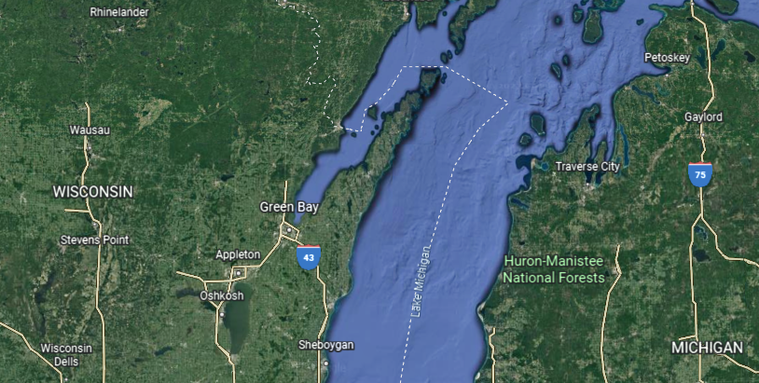
Figure 1. Door Peninsula, WI

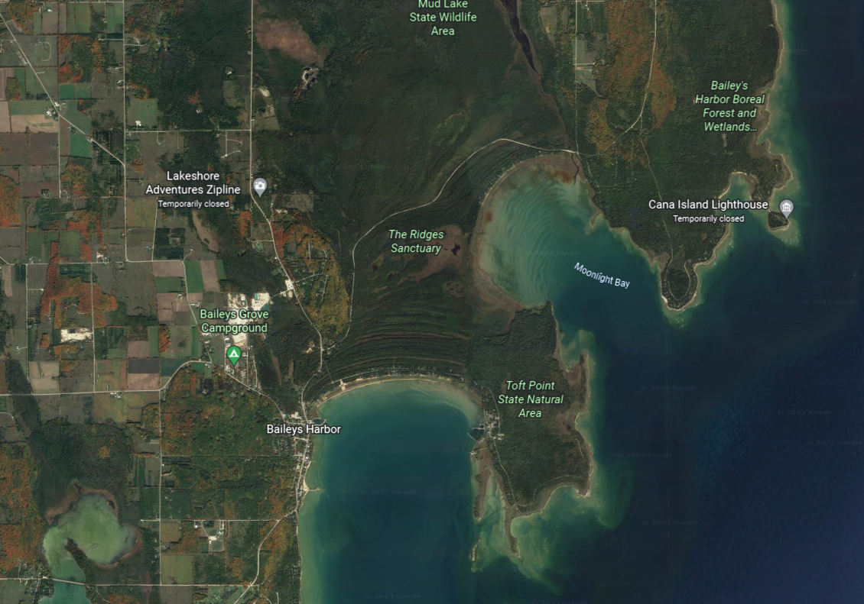
Figure 2. Baileys Harbor, Door County, WI.

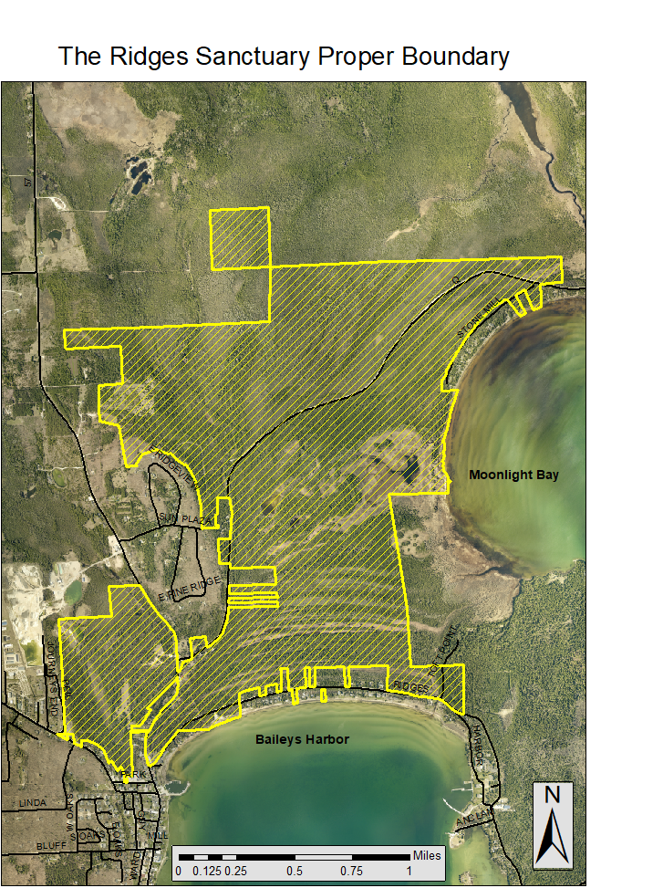
Figure 3. The Ridges Sanctuary Boundary w/ Range Light Corridor project area (red box) and Secondary Restoration Sites (red star).

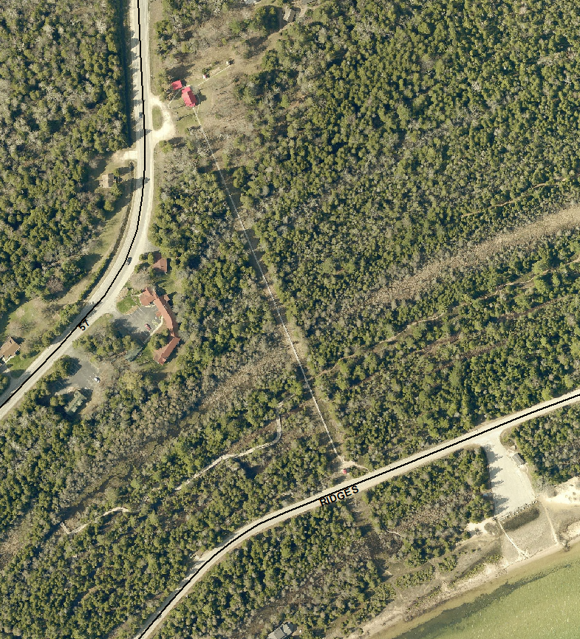
Figure 4. Range Light Corridor Project Area

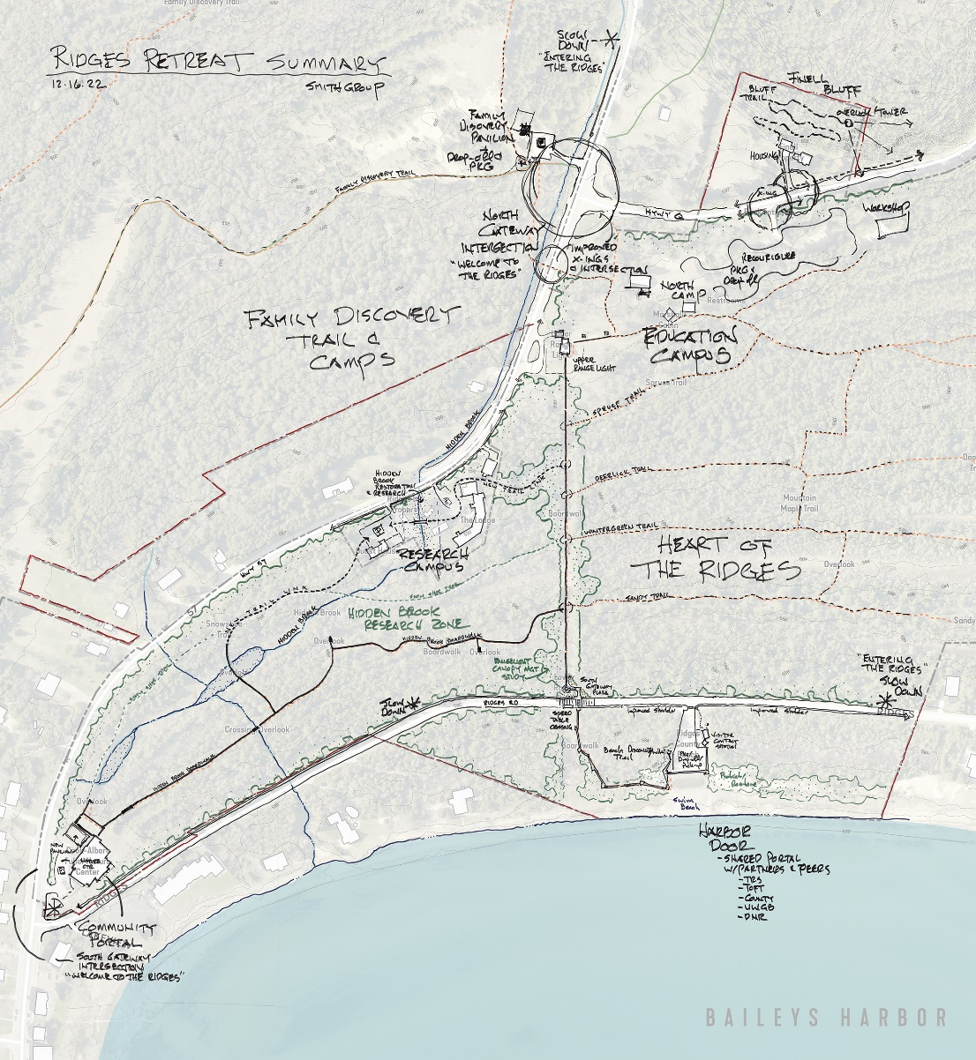
Figure 5. Concept for “feathering” on RLC project area.

References

Brotske, V., 2018. Pollination, Seed Dispersal, Germination, and Seedling Survival in the Federally Threatened DLI (Iris lacustris). Master’s thesis, UW-Green Bay Libraries Digital Collection. https://diglib.uwgb.edu/digital/collection/p17003coll1/id/46/rec/1

Doyle, K., 2015. DLI (Iris lacustris) project: Interim Report for USFWS. Unpublished manuscript, Wisconsin Department of Natural Resources.

Collins, D., 2020. Crossroads at Big Creek DLI Transplantation Project. Unpublished manuscript, Landscapes of Place. Dwarf+Lake+Iris+transplant+2020+draft.pdf (squarespace.com)

Morgan, M.D., and A.T. Wolf. 2008. A long-term study of the reproductive ecology of DLI (Iris lacustris) in northeastern Wisconsin. Unpublished manuscript, University of Wisconsin-Green Bay.

USFWS species info page: https://fws.gov/species/dwarf-lake-iris-iris-lacustris

WDNR species info page: https://dnr.wi.gov/topic/EndangeredResources/Plants.asp?mode=detail&SpecCode=PMIRI090H0

